1. 1. The subjects are the students in a grade 12 math class from a high school with the population of interest being the types of studying methods done in a learning environment. The response variable is the scores of a midterm exam taking place. The factors of this study is the type of studying being done to prepare for this midterm with their being 6 different groups(levels) to this factor.
   2. This is an experimental study as we are randomly assigning students to one of the 6 different groups(treatments). As this is an experimental study and we are randomly assigning students to different groups, we can make causal inferences which means we can establish a link between the different factors and the midterm scores. However, we can not make inferences on the population as we did not randomly select the sample from the population.

|  |  |  |  |
| --- | --- | --- | --- |
| **Report** | | | |
| SCORE | | | |
| STRAT | Mean | N | Std. Deviation |
| C | 61.43 | 20 | 7.480 |
| H | 78.59 | 20 | 6.972 |
| HT | 82.81 | 20 | 6.839 |
| Q | 61.74 | 20 | 6.813 |
| QT | 70.30 | 20 | 9.030 |
| T | 69.11 | 20 | 8.934 |
| Total | 70.66 | 120 | 10.993 |

Ranking all the means against each other, we can see that the level with the largest mean is the HT group with a mean of 82.81, with the next group being the H group with a mean of 78.59. Then, the 3rd largest mean is the QT group with a mean of 70.3 followed by the T group with a mean of 69.11. The Q group is the 5th largest mean with a mean of 61.74 followed by the lowest mean which the control group has(their mean was 61.43) . The largest standard deviation of all the 6 groups is 9.03 held by the QT group. Then group with the lowest standard deviation is the Q group with a standard deviation of 6.813. If we divide the largest by the lowest standard deviation, we get 1.3254 which is less than 2. This means we can assume equal variances for all 6 groups.

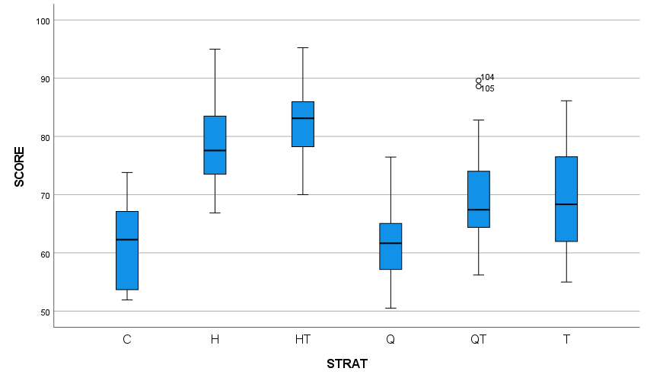

* 1. As seen from the box plots, none of the different groups are symmetric. For the control group, Q group and HT groups they are skewed to the left. For the H, QT and Q groups, they are skewed to the right. There are 2 outliers in the whole box plots and they belong to the QT group. Group Q has the lowest center out of all the groups at around 61.66 whereas the group with the largest center is group HT at around 83.11. The group with the largest Interquartile range is group T which had an interquartile range of 15 whereas groups Q and HT have the lowest interquartile range of 8. The control group had an interquartile range of 14, H had an interquartile range of 11 and QT had an interquartile range of 10.

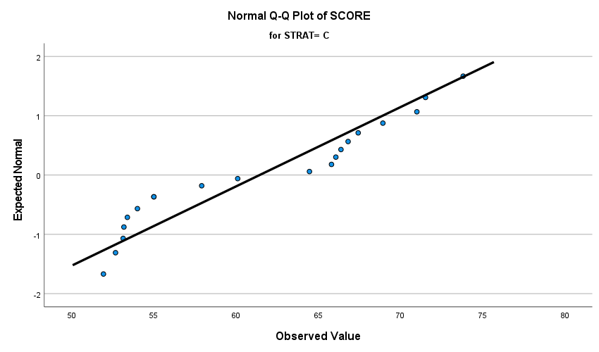

As seen from the Q-Q plot for the control group, many of the points are far away from the lines with the points trailing off. This indicates a violation of normality and a left skew as seen from above. For groups Q, HT&H, then tend to lie closer to the point, and they graph indicates a slight skew(supported by the box plot in that they do have a skew but not a large skew) so they don’t violate normality too much. Group T’s points lie a bit far away from the line but the points distance from the line are consistent, so they don’t violate normality as strongly as the control group. QT on the other hand lie quite far away from the point so that means there is a violation of normality and the graph shows that there is a skew(supported by the above box plot)

1. 1. Our null hypothesis is that the 6 different groups have the same mean(i.e. H0: µC= µQ= µQT= µH= µHT= µT) whereas our alternate hypothesis is that not all of the means are the exact same.(i.e. Ha : µC≠ µQ≠ µQT≠µH≠ µHT≠ µT)

|  |  |  |  |  |  |
| --- | --- | --- | --- | --- | --- |
| **ANOVA** | | | | | |
| SCORE | | | | | |
|  | Sum of Squares | df | Mean Square | F | Sig. |
| Between Groups | 7556.491 | 5 | 1511.298 | 25.250 | <.001 |
| Within Groups | 6823.208 | 114 | 59.853 |  |  |
| Total | 14379.699 | 119 |  |  |  |

Our sum of squares reduced is 14379.699 while our sum of squares full is 6823.208. Our pooled estimate of the population variance is 59.853. Our test statistics if 25.250 which is calculated from ( (14379.699-6823.208)/ (119-114) ) / ( 6823.208 /114) which gives us our test statistic of 25.250. The p value is approximately less than 0.001. To get this we use our null F distribution and the degrees of freedom of [5,114]. This means that to get our p-score, it is the probability of an F distributed random variable with 5 numerator and 114 denominator degrees of freedom being larger than our test statistic of 25.250 which is less than 0.001. This means at the 1% level, we reject our null hypothesis which means there is a difference between the mean test scores of the different test strategies.

1. * 1. (Provided to us) ɣH= -0.5 µ1+0.5 µ2 +0µ3-0.5 µ4+0.5 µ5 +0µ6
     2. ɣQ= -0.5µ1+0 µ2 + 0.5µ3 - 0.5 µ4 + 0 µ5 + 0.5µ6. The reason for this is we need to compare the control group to Group 3 which whose treatment is Q as no other components are there. Then we need to compare groups 6 and 4 as group 4 is Ttreatment and group 6 is treatment QT as computer tutorials are involved this time
     3. ɣT= -0.5µ1 - 0.5µ2 - 0.5µ3+ 0.5 µ4 + 0.5µ5 + 0.5µ6 . This is because we have 3 different effects we need to compare this time. Firstly, when there is no other component, we compare the control group to the group that is assigned just computer tutorials. Then we need to compare when homework is involved hence we compare groups HT and H. Finally, we need to take into account when quizzes are involved, thus comparing groups 3(Group H) and 5(Group HT).

|  |  |  |  |  |  |
| --- | --- | --- | --- | --- | --- |
| **ANOVA** | | | | | |
| SCORE | | | | | |
|  | Sum of Squares | df | Mean Square | F | Sig. |
| Between Groups | 7556.491 | 5 | 1511.298 | 25.250 | <.001 |
| Within Groups | 6823.208 | 114 | 59.853 |  |  |
| Total | 14379.699 | 119 |  |  |  |

|  |  |  |  |  |  |  |
| --- | --- | --- | --- | --- | --- | --- |
| **Contrast Coefficients** | | | | | | |
| Contrast | CODE | | | | | |
| C | H | Q | T | HT | QT |
| 1 | -.5 | .5 | 0 | -.5 | .5 | 0 |
| 2 | -.5 | 0 | .5 | -.5 | 0 | .5 |
| 3 | -.5 | -.5 | -.5 | .5 | .5 | .5 |

|  |  |  |  |  |  |  |  |  |  |
| --- | --- | --- | --- | --- | --- | --- | --- | --- | --- |
| **Contrast Tests** | | | | | | | | | |
|  |  | Contrast | Value of Contrast | Std. Error | t | df | Sig. (2-tailed) | 95% Confidence Interval | |
|  |  | Lower | Upper |
| SCORE | Assumes equal variances | 1 | 15.43 | 1.730 | 8.919 | 114 | <.001 | 12.00 | 18.86 |
| 2 | .75 | 1.730 | .434 | 114 | .665 | -2.68 | 4.18 |
| 3 | 10.23 | 2.119 | 4.829 | 114 | <.001 | 6.03 | 14.43 |
| Does not assume equal variances | 1 | 15.43 | 1.700 | 9.077 | 72.243 | <.001 | 12.04 | 18.82 |
| 2 | .75 | 1.816 | .413 | 72.191 | .681 | -2.87 | 4.37 |
| 3 | 10.23 | 2.119 | 4.829 | 107.202 | <.001 | 6.03 | 14.43 |

For test 1 we can see it has, on average, an effect of 15.43 points on the midterm score with a standard error of 1.73. It also has a test statistic of 8.919 with a df of 114 and a p score of less than 0.001. In conclusion, for contrast 1 we can reject our null hypothesis at the 5% significance level and can say that there is a difference in mean scores between providing homework and not providing homework. For contrast test 2 we can see it has, on average, a very small effect of .75 on the average test score with a standard error of 1.73. It has a test statistic of .434 and with 114 degrees of freedom with a P Score of .665. That means we fail to reject the null hypothesis due to insufficient evidence in the 5% significance level as our P score is greater than our alpha. Finally, for test 3 it has an effect of 10.23 on average on midterm test scores with a standard error of 2.119. It has a test statistic of 4.829 with 114 degrees of freedom and a p-score of less than 0.001. That means we can reject our null hypothesis at the 5% significance level which means there is a difference between mean midterm scores between those who had computer tutorials and those who did not have computer tutorials. We can also determine that providing homework has the most influential effect on mid-term scores whereas providing weekly quizzes is the least influential on mid-term scores.

* 1. Given our contrast value of 10.23 and our standard error of 2.119, to calculate our critical value we first divide our alpha value of 0.1 by 2 to get 0.05. We then look up our critical value based on our alpha/2 and our df of 114 we get a critical value of 1.66. We then multiply 1.66 by our standard error and we get 3.51754. That means out confidence interval is [10.23-3.51754,10.23+3.51754] which is the same as [6.71246,13.74754]. That means we reject the null hypothesis in the 10% significance level which means there is a difference in mean scores when using computer tutorials and not using them.
  2. ɣH -ɣQ = 0µ1 + 0.5µ2 - 0.5µ3+ 0µ4 + 0.5µ5 - 0.5µ6 will be our new linear contrast. With this contrast we get a contrast value of 14.68 with a standard error of 1.73. Using our alpha of 0.01 and divide that by 2, we get 0.005. This alongside our df of 114, we get a critical value of 2.626. 1.73*2.626= 4.54298. That means our confidence interval is [14.68-4.54298,14.68+4.54298] = [10.13702,19.22298]. Therefore at the 1% significance level, we reject our null hypothesis which means that there is a difference in the effects of homework and the effects of quizzes.



|  |  |  |  |  |  |  |  |
| --- | --- | --- | --- | --- | --- | --- | --- |
| **Multiple Comparisons** | | | | | | | |
| Dependent Variable: SCORE | | | | | | | |
|  | (I) CODE | (J) CODE | Mean Difference (I-J) | Std. Error | Sig. | 95% Confidence Interval | |
|  | Lower Bound | Upper Bound |
| Scheffe | C | H | -17.166* | 2.446 | <.001 | -25.45 | -8.88 |
| Q | -.315 | 2.446 | 1.000 | -8.60 | 7.97 |
| T | -7.688 | 2.446 | .088 | -15.97 | .60 |
| HT | -21.382* | 2.446 | <.001 | -29.67 | -13.10 |
| QT | -8.873* | 2.446 | .027 | -17.16 | -.59 |
| H | C | 17.166* | 2.446 | <.001 | 8.88 | 25.45 |
| Q | 16.851* | 2.446 | <.001 | 8.57 | 25.14 |
| T | 9.478* | 2.446 | .014 | 1.19 | 17.76 |
| HT | -4.216 | 2.446 | .705 | -12.50 | 4.07 |
| QT | 8.292* | 2.446 | .050 | .01 | 16.58 |
| Q | C | .315 | 2.446 | 1.000 | -7.97 | 8.60 |
| H | -16.851* | 2.446 | <.001 | -25.14 | -8.57 |
| T | -7.373 | 2.446 | .115 | -15.66 | .91 |
| HT | -21.067* | 2.446 | <.001 | -29.35 | -12.78 |
| QT | -8.559* | 2.446 | .038 | -16.84 | -.27 |
| T | C | 7.688 | 2.446 | .088 | -.60 | 15.97 |
| H | -9.478* | 2.446 | .014 | -17.76 | -1.19 |
| Q | 7.373 | 2.446 | .115 | -.91 | 15.66 |
| HT | -13.694* | 2.446 | <.001 | -21.98 | -5.41 |
| QT | -1.186 | 2.446 | .999 | -9.47 | 7.10 |
| HT | C | 21.382* | 2.446 | <.001 | 13.10 | 29.67 |
| H | 4.216 | 2.446 | .705 | -4.07 | 12.50 |
| Q | 21.067* | 2.446 | <.001 | 12.78 | 29.35 |
| T | 13.694* | 2.446 | <.001 | 5.41 | 21.98 |
| QT | 12.508* | 2.446 | <.001 | 4.22 | 20.79 |
| QT | C | 8.873* | 2.446 | .027 | .59 | 17.16 |
| H | -8.292* | 2.446 | .050 | -16.58 | -.01 |
| Q | 8.559* | 2.446 | .038 | .27 | 16.84 |
| T | 1.186 | 2.446 | .999 | -7.10 | 9.47 |
| HT | -12.508* | 2.446 | <.001 | -20.79 | -4.22 |
| Bonferroni | C | H | -17.166* | 2.446 | <.001 | -24.50 | -9.83 |
| Q | -.315 | 2.446 | 1.000 | -7.65 | 7.02 |
| T | -7.688* | 2.446 | .032 | -15.02 | -.35 |
| HT | -21.382* | 2.446 | <.001 | -28.72 | -14.05 |
| QT | -8.873* | 2.446 | .006 | -16.21 | -1.54 |
| H | C | 17.166* | 2.446 | <.001 | 9.83 | 24.50 |
| Q | 16.851* | 2.446 | <.001 | 9.52 | 24.19 |
| T | 9.478* | 2.446 | .003 | 2.14 | 16.81 |
| HT | -4.216 | 2.446 | 1.000 | -11.55 | 3.12 |
| QT | 8.292* | 2.446 | .014 | .96 | 15.63 |
| Q | C | .315 | 2.446 | 1.000 | -7.02 | 7.65 |
| H | -16.851* | 2.446 | <.001 | -24.19 | -9.52 |
| T | -7.373* | 2.446 | .048 | -14.71 | -.04 |
| HT | -21.067* | 2.446 | <.001 | -28.40 | -13.73 |
| QT | -8.559* | 2.446 | .010 | -15.89 | -1.22 |
| T | C | 7.688* | 2.446 | .032 | .35 | 15.02 |
| H | -9.478* | 2.446 | .003 | -16.81 | -2.14 |
| Q | 7.373* | 2.446 | .048 | .04 | 14.71 |
| HT | -13.694* | 2.446 | <.001 | -21.03 | -6.36 |
| QT | -1.186 | 2.446 | 1.000 | -8.52 | 6.15 |
| HT | C | 21.382* | 2.446 | <.001 | 14.05 | 28.72 |
| H | 4.216 | 2.446 | 1.000 | -3.12 | 11.55 |
| Q | 21.067* | 2.446 | <.001 | 13.73 | 28.40 |
| T | 13.694* | 2.446 | <.001 | 6.36 | 21.03 |
| QT | 12.508* | 2.446 | <.001 | 5.17 | 19.84 |
| QT | C | 8.873* | 2.446 | .006 | 1.54 | 16.21 |
| H | -8.292* | 2.446 | .014 | -15.63 | -.96 |
| Q | 8.559* | 2.446 | .010 | 1.22 | 15.89 |
| T | 1.186 | 2.446 | 1.000 | -6.15 | 8.52 |
| HT | -12.508* | 2.446 | <.001 | -19.84 | -5.17 |
| *. The mean difference is significant at the 0.05 level. | | | | | | | |

Scheffe Means Diagram:

C Q T QT H HT

Bonferroni Means Diagram:

C Q T QT H HT

Using the results from SPSS and the Means comparison diagrams above. We notice that the Bonferroni method is more accurate than the Scheffe method. This is because in Scheffe, we say that there is no significant difference between groups Q and T and between C and T whereas Bonferroni states otherwise. That means we see there is a difference in mean midterm scores between the Control and groups QT, H, HT( and group T when using Bonferroni). There is a difference in mean scores between groups Q and every other group except the control and, if using Scheffe, group T. There is a difference in mean scores between groups t and every other group except group QT. Finally, for groups H and HT, there is no difference between them yet those 2 groups differ in mean scores than every other group. In total, Scheffe’s method states there are 10 differences in mean scores between groups whereas Bonferroni states there is 12 differences in mean scores between groups. The reason for the difference in number of differences is because Scheffe’s method gives us a wider confidence interval so it is less precise than Bonferroni’s which allows us to control overall error rate.

|  |  |  |  |  |  |
| --- | --- | --- | --- | --- | --- |
| **ANOVA** | | | | | |
| SCORE | | | | | |
|  | Sum of Squares | df | Mean Square | F | Sig. |
| Between Groups | 7541.445 | 3 | 2513.815 | 42.643 | <.001 |
| Within Groups | 6838.254 | 116 | 58.950 |  |  |
| Total | 14379.699 | 119 |  |  |  |

Our reduced sum of squares(6 mean model) is 14379.699 while our sum of squares full( 4 mean model) is 6838.254. Our reduced df is 119 whereas our full df is 116. Our test statistics if 42.643 which is calculated from ( (14379.699-6838.254)/ (119-116) ) / ( 6838.254/116) which gives us our test statistic of 42.643. The p value is approximately less than 0.001. To get this we use our null F distribution and the degrees of freedom of [3,116]. This means that to get our p-score, it is the probability of an F distributed random variable with 3 numerator and 116 denominator degrees of freedom being larger than our test statistic of 42.643which is less than 0.001. This means we reject our null hypothesis which means we should use the 6 mean model rather than the 4 mean model.